How Delta-8 THC Works — and Why Experts Are Worried About It
This popular cannabis product claims to be milder than regular marijuana. But is it legal? And is it safe?
Credit...Johnathon Kelso for The New York Times
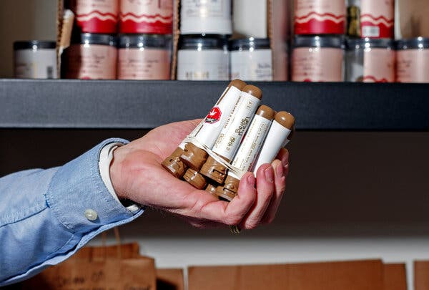
By Dana G Smith
Published July 1, 2022Updated July 7, 2022
Over the past few years, you may have seen headlines about a drug called delta-8. Google searches for the term grew by more than 850 percent in the United States between 2020 and 2021, particularly in states where recreational marijuana is illegal. According to one recent study, 16 percent of regular marijuana users also use delta-8.
Some claim it’s the next big thing in cannabis: a gentler and, perhaps more crucially, legal high that offers relaxation and pain relief without the anxiety or fuzzy-headedness of regular weed.
But recent warnings from the Centers for Disease Control and Prevention and the Food and Drug Administration say delta-8 is a potentially dangerous drug that’s resulted in thousands of accidental poisonings.
Is this a case of regulators being too cautious or of cannabis advocates getting too hyped? The answer depends on what’s actually in a product labeled delta-8.
Some early research supports the claim that delta-8 could cause a milder high than traditional marijuana. But because the drug is unregulated, the vast majority of delta-8 products on the market don’t resemble what’s tested in a lab and can be contaminated with other cannabinoids and heavy metals. As a result, many experts advise against its use.

What is delta-8?
Technically, delta-8 means delta-8-THC, as in the THC that’s the primary psychoactive ingredient in marijuana.
The most common form of THC in cannabis plants is delta-9-THC, which is almost identical to delta-8-THC in its chemical structure. The molecules’ similarity means that delta-8 and delta-9 act very similarly in the body. Most crucially, they both bind to the same receptors in the brain, particularly one called the cannabinoid type 1 (or CB1) receptor, which produces the high you experience when you smoke a joint or eat a weed gummy.
However, research suggests delta-8 has a slightly weaker attachment to the CB1 receptor than delta-9, which tempers its effect. Delta-8-THC is less potent than delta-9-THC,” said Linda Klumpers, co-founder of Verdient Science, a pharmacology consulting company that specializes in cannabis-based medicines. “If you want to achieve the same effect as delta-9-THC, you need to give a higher dose of delta-8.”

Why are people using it?
A survey of delta-8 users backs this up, with respondents reporting feeling less paranoid, less anxious and having a “nicer” high compared with delta-9-THC. The most common experiences when using delta-8 were relaxation, euphoria and pain relief. People did report having some difficulty concentrating, problems with short-term memory and an altered sense of time, although not to the same extent as with regular marijuana.
“When we asked participants to compare delta-8 to delta-9, they felt that it was less intense,” said Jessica Kruger, a clinical assistant professor of health behavior at the University at Buffalo, who led the survey. “They remarked how they could use delta-8 and still be productive, whereas when they use delta-9 they would say that they had things like ‘couch lock’ or didn’t feel like getting up and doing anything.”
Dr. Kruger and Dr. Klumpers said it’s unlikely that delta-8 has different effects than delta-9. Instead, experts said, the explanation is probably that there’s less of the drug in the CB1 receptors, so people are less likely to experience the more distressing symptoms that can occur when they get too high.

Is it legal?
The purportedly milder high is one of delta-8’s main attractions for users. The other is its legal status.
Delta-8’s rise started with the passing of the 2018 Farm Bill, which made hemp legal. Hemp and marijuana are both types of cannabis plants, but marijuana produces delta-9-THC and hemp doesn’t. Think of hemp and marijuana like two varieties of tomato plants, if one type of tomato could get you high.
The Farm Bill stated that hemp could be grown legally as long as it contained less than 0.3 percent THC. But, said Kent Vrana, a professor of pharmacology at Penn State, the authors of the bill made an oversight: They defined THC specifically as delta-9-THC, which is still illegal federally. With that definition, a market for delta-8 was born.

Delta-8-THC is detectable only in trace amounts in both hemp and marijuana plants, but manufacturers have figured out a way to produce it from a third notable chemical in cannabis plants, CBD. CBD is present in large quantities in hemp plants, and because CBD is legal, they assert, so is delta-8.
“What these manufacturers are arguing is that since you can extract CBD from hemp, and CBD is not THC, that it’s still considered hemp,” said Eric Leas, an assistant professor of public health at the University of California, San Diego. In other words, delta-8 is chemically THC, but legally hemp.
The manufactured delta-8-THC is typically added to gummies and vape cartridges and sold legally over the internet and in stores. But because the products are unregulated, what’s on the label can differ from what’s inside the package, both in terms of the potency of delta-8 and other unanticipated ingredients, like delta-9.

Is it dangerous?
The lack of regulation in the United States around delta-8 is the biggest concern for many public health experts. Several studies, including one by the US Cannabis Council, have found contaminants in delta-8 products. In another paper published in December by scientists at the University of Rochester, none of the 27 delta-8 products tested contained the amount of delta-8 they claimed. What’s more, all 27 had potentially harmful byproducts, presumably from the manufacturing process, including other cannabinoids, like delta-9-THC, and heavy metals, including lead and mercury.
“I don’t think delta-8 by itself is more dangerous than delta-9, but the way it’s made and who is selling it just scares the heck out of me,” Dr. Vrana said. “It’s unregulated, and because it’s synthetic there are plenty of opportunities for things to go wrong.”
Because of these concerns, the C.D.C. issued a health advisory about delta-8 in September. The F.D.A. put out a similar warning in May after receiving 104 reports of adverse events from delta-8 use, including hallucinations, vomiting, tremor, anxiety, dizziness, confusion and loss of consciousness.
Similarly, national poison control centers handled over 2,000 calls about delta-8 between January 2021 and February 2022, 41 percent of which involved children accidentally ingesting products with delta-8 in them. One of those cases resulted in death.

These poisonings could be caused by contaminants, or consuming large quantities of delta-8 or unlabeled delta-9. THC can cause chronic vomiting, psychosis and addiction when used at high concentrations.
Facing a lack of federal regulation, 14 states have banned either delta-8 or all unregulated forms of THC (there’s a delta-10, too). Surprisingly, this includes several states where recreational marijuana is legal, including Colorado and New York. According to Dr. Leas, the regulatory system for recreational marijuana makes it a safer product than delta-8. He points to manufacturing quality checks as important public health standards. In theory, the licensing of distributors, existing age limits and labeling rules about potency and recommended dose of a product — plus confirmation requirements for those labels — should protect consumers. None of those protections exist for delta-8-THC.
All the experts interviewed for this article, including those supportive of legalizing marijuana, recommended against using delta-8, because there is no way to ensure its safety. However, they also said the best solution is not to ban delta-8 but to regulate it.
“Regulation, for me as a pharmacologist and toxicologist, is: ‘What’s in it?’” said Dr. Vrana. “You have every right to know precisely what you’re taking.”

